

Ahsanullah University of Science and Technology

*Department of Computer Science and Engineering*

CSE 3200: Software Development-V

Fall 2022

Project Final Report

Project Name : ADD YOUR AD

Lab Group: A2

Project Group: 4

=: Submitted To :=

Muhammad Yaseen Morshed Adib

Ms. Nowrin Tabassum

=: Submitted By :=

Aurprita Mahmood 20200104035

Meherin Sultana 20200104036

Yasir Arafah Prince 20200104042

Sumaiya Shejin 20200104043

Contents

1 Introduction . . . . . . . . . . . . . . . . . . . . . . . . . . . . . . . . . . . . . . . . . . . . . . . . . . . . .3

1.1 Proposed Goals . . . . . . . . . . . . . . . . . . . . . . . . . . . . . . . . . . . . . . . . . . . . . . . . . 3

1.2 Project Accomplishment . . . . . . . . . . . . . . . . . . . . . . . . . . . . . . . . . . . . . . . . . . . .3

2 Project Features . . . . . . . . . . . . . . . . . . . . . . . . . . . . . . . . . . . . . . . . . . . . . . . . . . 3

3 Database Diagram . . . . . . . . . . . . . . . . . . . . . . . . . . . . . . . . . . . . . . . . . . . . . . . . 4

3.1 Proposed Diagram . . . . . . . . . . . . . . . . . . . . . . . . . . . . . . . . . . . . . . . . . . . . . . . 4

3.2 Evaluation 1 Diagram . . . . . . . . . . . . . . . . . . . . . . . . . . . . . . . . . . . . . . . . . . . . . .5

3.3 Final Diagram . . . . . . . . . . . . . . . . . . . . . . . . . . . . . . . . . . . . . . . . . . . . . . . . . . . 6

4 Contribution . . . . . . . . . . . . . . . . . . . . . . . . . . . . . . . . . . . . . . . . . . . . . . . . . . . . . .7

5 Conclusion . . . . . . . . . . . . . . . . . . . . . . . . . . . . . . . . . . . . . . . . . . . . . . . . . . . . . . 7

5.1 Limitations . . . . . . . . . . . . . . . . . . . . . . . . . . . . . . . . . . . . . . . . . . . . . . . . . . . . .8

5.2 Future Work . . . . . . . . . . . . . . . . . . . . . . . . . . . . . . . . . . . . . . . . . . . . . . . . . . . 8

5.3 Project Link . . . . . . . . . . . . . . . . . . . . . . . . . . . . . . . . . . . . . . . . . . . . . . . . . . . .8

5.4 Ending Remarks . . . . . . . . . . . . . . . . . . . . . . . . . . . . . . . . . . . . . . . . . . . . . . . .. 8

**1 Introduction**

Our project is a responsive dynamic buying and selling website. It is a classified advertisement website where people can buy and sell almost everything. In this platform there are more than 20 categories like cars, bikes, electronic products, cosmetics and much more. Our project is built to be safe, smart and convenient for our customers.

**1.1 Proposed Goals**

I once wanted to sell some of my unused products a little faster that might be useful to others but I could not find any trustworthy websites for it. This limitation of online E-Marketing websites prompted me to think of something different, so me and my teammates came up with the idea of building and launching a website where users can sell things easily.

As ours is an E-Marketing platform, thousands of unique visitors and interested buyers can visit our website. To sell something faster, our website helps a lot because the audience is wider, making it easier for sellers to find someone interested in the items they are selling.

**1.2 Project Accomplishment**

We have been able to complete our proposed project completely. In our project proposal, we hoped to build an E-Marketing platform where users can buy and sell things easily and can find the products in a sorted category. Some of the important features of our project are posting an ad, purchasing, login, signing up etc. After completion of the project, we can maintain all the details about products and users. The efficiency, interface, effectiveness, accuracy, information availability, and easy maintenance makes our project different from other systems. We are pretty much satisfied with our project. If we had more time then we could have optimized it further.

**2. Project Features**

The main features of our project is given below :

1. In our homepage, users **can see** the product categories. Users can go to other procedures or different pages using **navbar**. The **homepage** contains an overview of our website.

2. To **remove** a particular ad, users have to sign in and then he/she can remove his ad only that he/she has posted.

3. Remove ad option is **disabled** for other users who didn’t add the advertisement.

4. Using the password and email address which they provide during sign-up, users can **sign-in** into the platform anytime.

5. Users can easily reach their desired products using the **search bar** with speed and relevance.

6. Users can now **post ads** in many categories for their own convenience. Sellers can even remove the advertisement easily just by clicking one button.

7. Users can also **purchase** products from our website according to their own choice.

8. Users **cannot provide wrong inputs** like Phone No, Nid No or wrong Email Addresses.

9. Admin has **Admin Dashboards**.

10. Admin can **Add**, **Delete** and **Visit** Categories.

11. Easy **admin navigation**.

In the proposed feature we did not keep any option for purchasing any product from our website. While working on our project we thought we could add this feature for more efficient and useful usage of the website and worked according to it. We also updated our User Interface for the convenience of the users. Our website also did not have any authentication system while signing up so we added the NID information input option in our website.

**3. Database Diagram :**

We initially proposed our website from a different perspective which was only to post ads. But now we have made a few modifications for the benefit of the user. Our proposed ERD and the modified ERD is given below :

**3.1 Proposed Diagram**

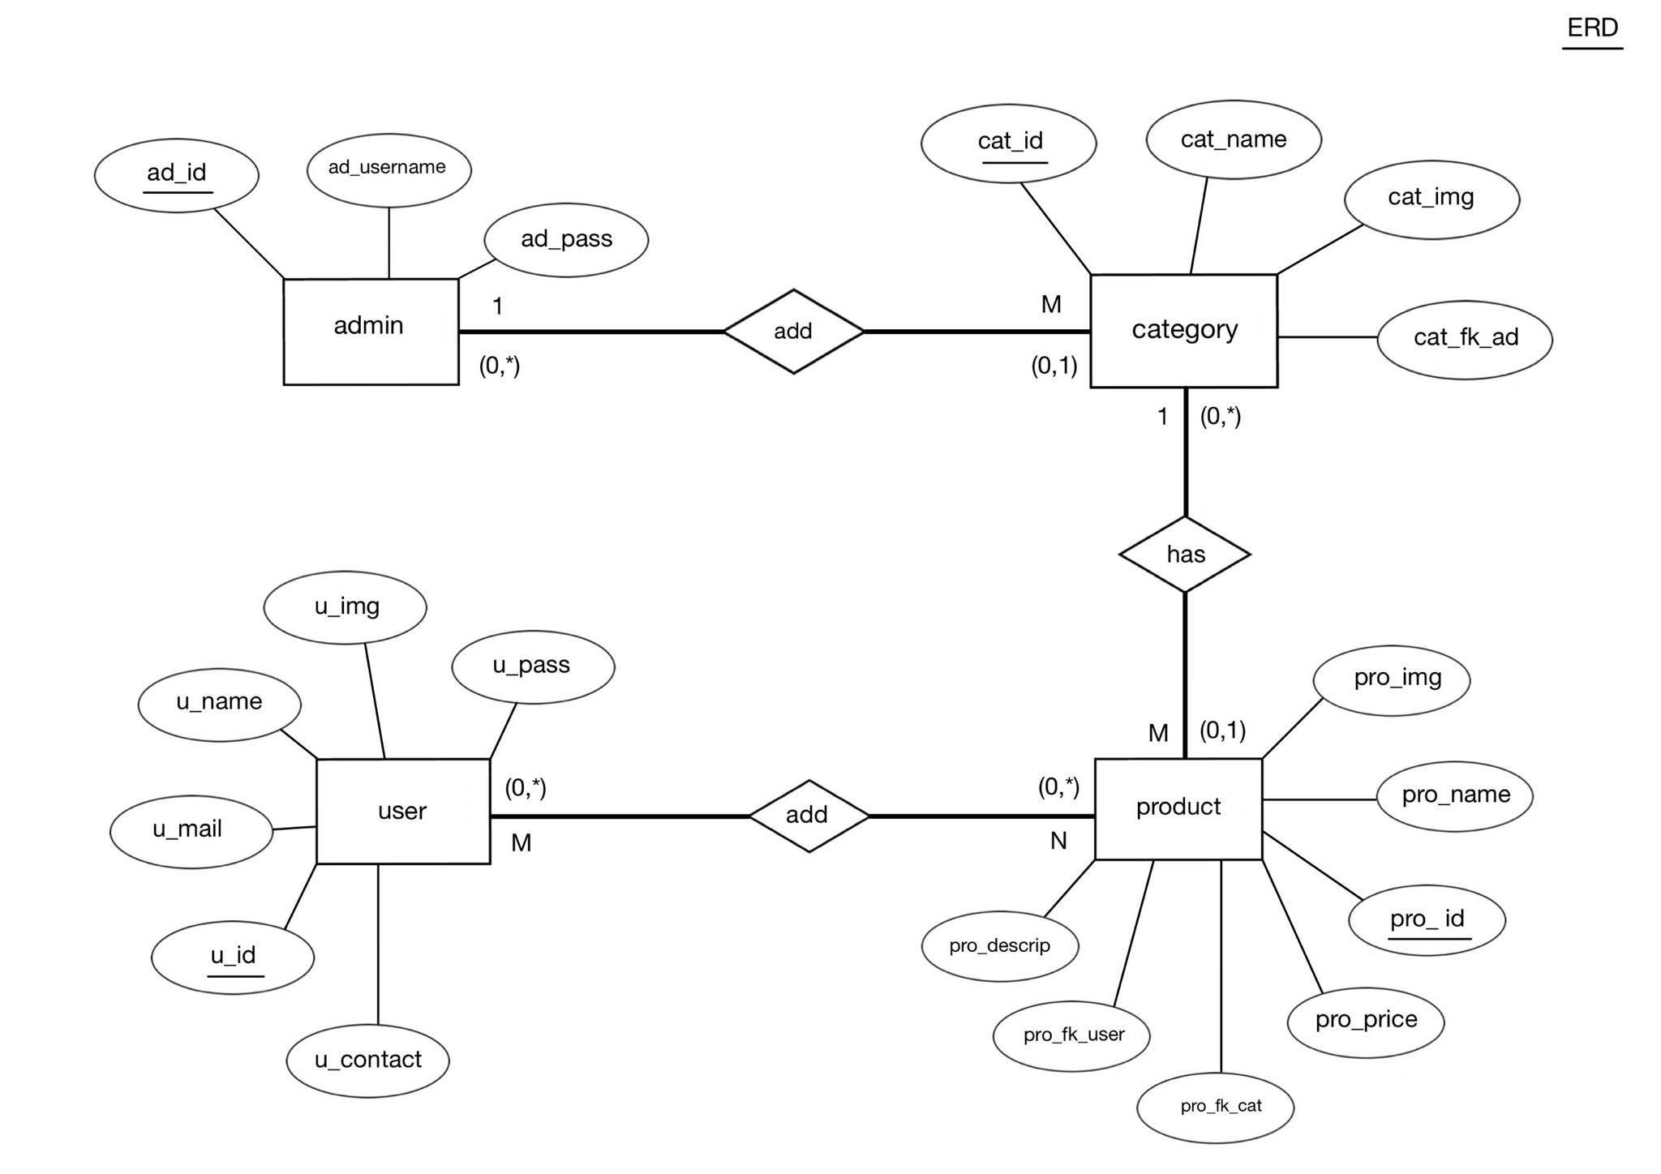

Figure 1: Proposed Diagram

**Limitations**

* We did not have Nid No and Nid_img to verify the user.
* We did not have any invoice and order table to store all sorts of related data.

**3.2 Evaluation 1 Diagram**

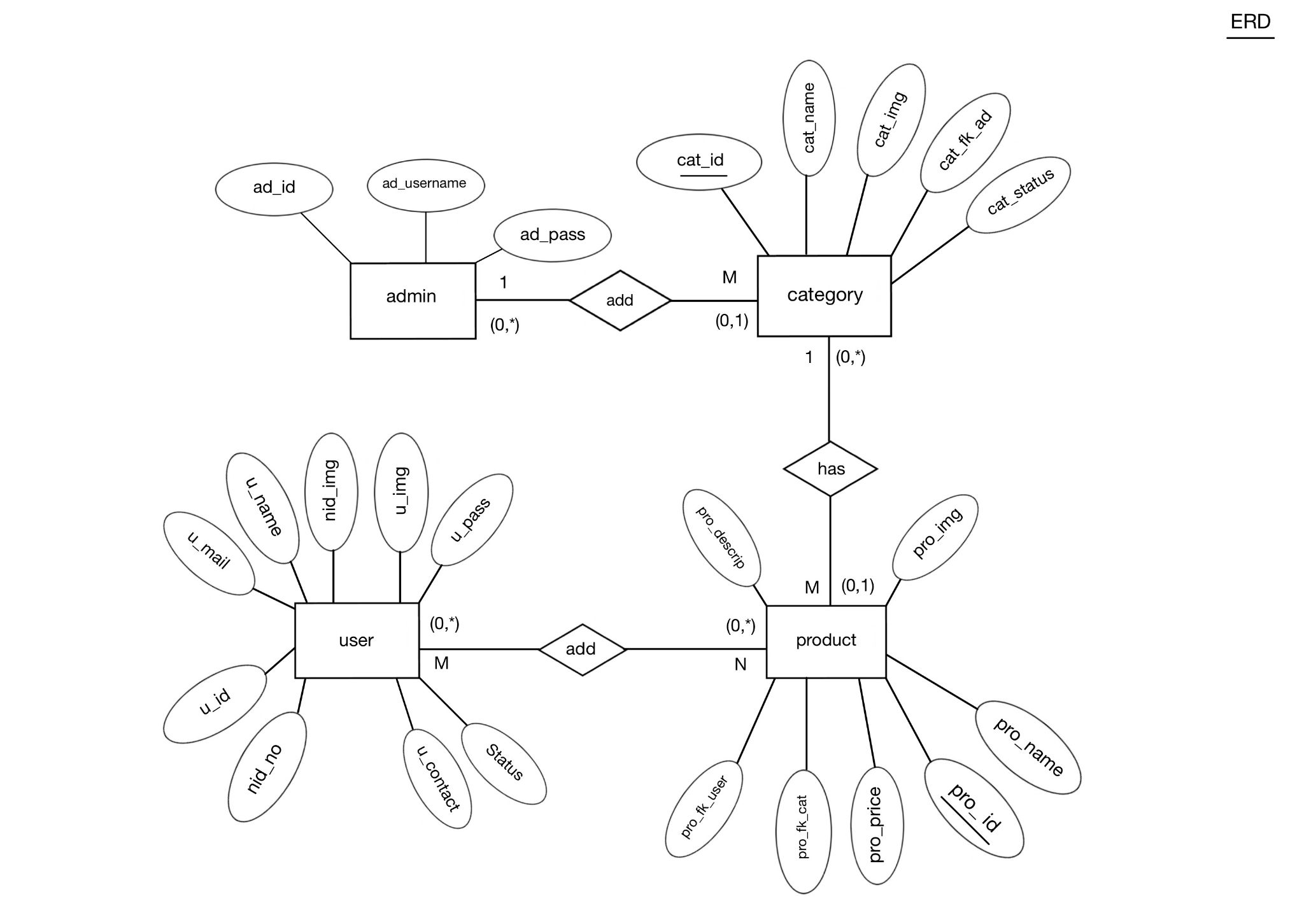

Figure 2: Evaluation 1 Diagram

**Limitations**

Our initial idea was only to communicate between the buyer and seller through the contact information provided in the product description. We did not have any purchase option for the users.

**3.3 Final Diagram**

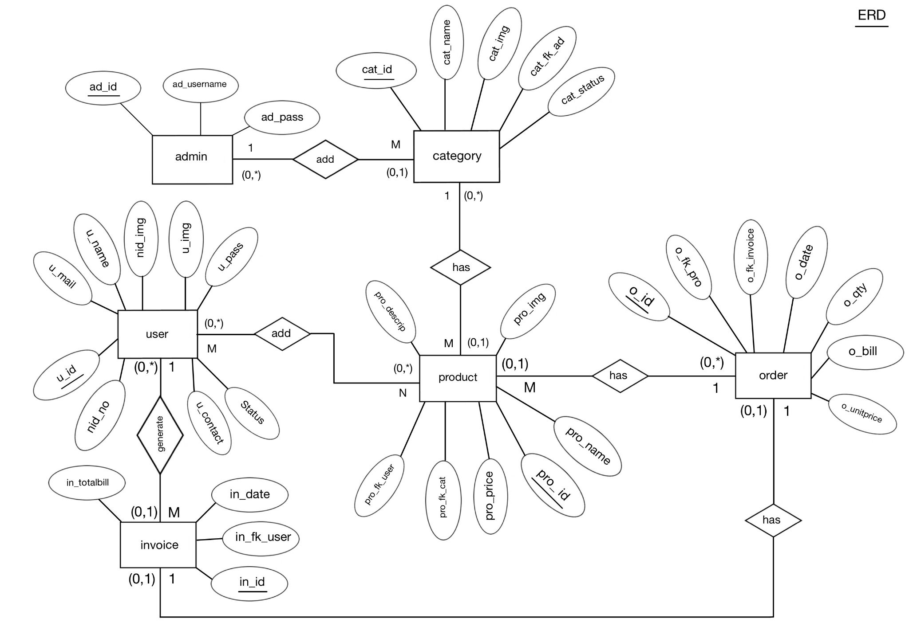

Figure 3: Final Diagram

**4 Contribution :**

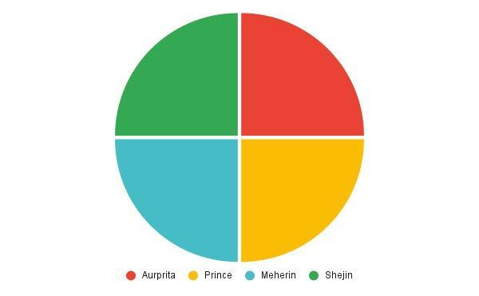

Aurprita Mahmood : Add category, Delete category, Visit category.

Yasir Arafah Prince : Add to cart, Checkout, User-Interface.

Meherin Sultana : Login, Sign-up, Admin-Dashboard.

Sumaiya Shejin : Sign-Out, Description, User-Interface.

**5 Conclusion**

The system developed is able to meet all the basic requirements. The users will also be benefitted by the system as it automates the whole procedure.The selling process of the respective products is faster than any usual website. The main advantage is, this system is flexible for future modifications. The main focus was to cover all the user requirements and make it more user friendly.

**5.1 Limitations**

When the user purchases any product using our website, they are not able to share their feedback and reviews about the website. They are unable to share their thoughts about the product. If we had this feature in our website we could have improved the website and worked on solving their difficulties.

**5.2 Future Work**

1. The website can be modified into faster, stable and secure web hosting. We can also work on making the website highly responsive for mobile phone users. We can make a review page as well.

2. The User Interface can be improved further.

3. More Payment option can be included

4. Searching can be done by categories also, currently searching only for particular product.

**5.3 Project Link**

The project link could be found

**5.4 Ending Remarks**

Management system helps to determine business decisions and organize everything effectively. All the user details and their transaction details are stored in a database. The users are greatly benefited from this website as they are able to purchase their desired products through only one click.